**Cryptography & Network Security**

**PRN - 2019BTECS00026**

**Name - Niraja Vasudev Kulkarni**

**Batch - B1**

**Assignment - 7**

* **Title:** Advanced Encryption Standard
* **Aim:** To Demonstrate Advanced Encryption Standard
* **Theory:**

AES algorithm (Rijndael algorithm) is a symmetric block cipher algorithm. The length of the data packet must be 128 bits, and the length of the key used should be 128, 192 or 256 bits. For three AES algorithms with different key lengths, they are called "AES-128", "AES-192", "AES-256".

* **Code:**

decoding.h

*/\**

*this header file implements the algorithm for 128-bit decryption*

*\*/*

#include<iostream>

#include "lookup_table_decoding.h"

#include "key_expand.h"

using namespace std;

void decryption(unsigned char *\** temp,unsigned char *\** extendedkeys)

{

    int kp=10;

    while(kp>0)

    {

*//subtract round key*

        for(int i=0;i<16;i++)

        {

            temp[i]^=extendedkeys[(kp*16)+i];

        }

*//inverse mix column step*

        if(kp<10){

         unsigned char temp2[16];

            for (int i = 0; i < 16; i++)

             {

             temp2[i] = temp[i];

             }

        temp[0] = (unsigned char)lookup14[temp2[0]] ^ lookup11[temp2[1]] ^ lookup13[temp2[2]] ^ lookup9[temp2[3]];

        temp[1] = (unsigned char)lookup9[temp2[0]] ^ lookup14[temp2[1]] ^ lookup11[temp2[2]] ^ lookup13[temp2[3]];

        temp[2] = (unsigned char)lookup13[temp2[0]] ^ lookup9[temp2[1]] ^ lookup14[temp2[2]] ^ lookup11[temp2[3]];

        temp[3] = (unsigned char)lookup11[temp2[0]] ^ lookup13[temp2[1]] ^ lookup9[temp2[2]] ^ lookup14[temp2[3]];

        temp[4] = (unsigned char)lookup14[temp2[4]] ^ lookup11[temp2[5]] ^ lookup13[temp2[6]] ^ lookup9[temp2[7]];

        temp[5] = (unsigned char)lookup9[temp2[4]] ^ lookup14[temp2[5]] ^ lookup11[temp2[6]] ^ lookup13[temp2[7]];

        temp[6] = (unsigned char)lookup13[temp2[4]] ^ lookup9[temp2[5]] ^ lookup14[temp2[6]] ^ lookup11[temp2[7]];

        temp[7] = (unsigned char)lookup11[temp2[4]] ^ lookup13[temp2[5]] ^ lookup9[temp2[6]] ^ lookup14[temp2[7]];

        temp[8] = (unsigned char)lookup14[temp2[8]] ^ lookup11[temp2[9]] ^ lookup13[temp2[10]] ^ lookup9[temp2[11]];

        temp[9] = (unsigned char)lookup9[temp2[8]] ^ lookup14[temp2[9]] ^ lookup11[temp2[10]] ^ lookup13[temp2[11]];

        temp[10] = (unsigned char)lookup13[temp2[8]] ^ lookup9[temp2[9]] ^ lookup14[temp2[10]] ^ lookup11[temp2[11]];

        temp[11] = (unsigned char)lookup11[temp2[8]] ^ lookup13[temp2[9]] ^ lookup9[temp2[10]] ^ lookup14[temp2[11]];

        temp[12] = (unsigned char)lookup14[temp2[12]] ^ lookup11[temp2[13]] ^ lookup13[temp2[14]] ^ lookup9[temp2[15]];

        temp[13] = (unsigned char)lookup9[temp2[12]] ^ lookup14[temp2[13]] ^lookup11[temp2[14]] ^ lookup13[temp2[15]];

        temp[14] = (unsigned char)lookup13[temp2[12]] ^ lookup9[temp2[13]] ^ lookup14[temp2[14]] ^ lookup11[temp2[15]];

        temp[15] = (unsigned char)lookup11[temp2[12]] ^ lookup13[temp2[13]] ^ lookup9[temp2[14]] ^ lookup14[temp2[15]];

        }

*// Shifts rows right*

        unsigned char temp2[16];

        for (int i = 0; i < 16; i++)

         {

        temp2[i] = temp[i];

         }

*//column one*

        temp [0] = temp2[0];

        temp [4] = temp2[4];

        temp [8] = temp2[8];

        temp [12] = temp2[12];

*//column two*

        temp [1] = temp2[13];

        temp [5] = temp2[1];

        temp [9] = temp2[5];

        temp [13] = temp2[9];

*//column three*

        temp [2] = temp2[10];

        temp [6] = temp2[14];

        temp [10] = temp2[2];

        temp [14] = temp2[6];

*//column four*

        temp [3] = temp2[7];

        temp [7] = temp2[11];

        temp [11] = temp2[15];

        temp [15] = temp2[3];

*//substitution bits*

        for(int i=0;i<16;i++)

         {

            temp[i]=in_sbox[temp[i]];

         }

         kp--;

       }

*//subtract round key*

        for(int i=0;i<16;i++)

        {

            temp[i]^=extendedkeys[i];

        }

}

encoding.h

*/\**

*this header file implements the algorithm for 128-bit encryption*

*\*/*

#include<iostream>

#include "lookup_table_encoding.h"

#include "key_expand.h"

using namespace std;

void encryption(unsigned char *\** temp,unsigned char *\** extendedkeys )

{

    int kp=0;

    for(int i=0;i<16;i++)

    {

        temp[i]^=extendedkeys[i];

    }

    kp++;

    while(kp<11)

    {

*//substitution bits*

          for(int i=0;i<16;i++)

          {

              temp[i]=sbox[temp[i]];

          }

*//shift row*

          unsigned char * temp2 = new unsigned char[16];

           for(int i=0;i<16;i++)

           temp2[i]=temp[i];

*//1st column*

           temp[0]=temp2[0];

           temp[4]=temp2[4];

           temp[8]=temp2[8];

           temp[12]=temp2[12];

*//2nd column*

           temp[1]=temp2[5];

           temp[5]=temp2[9];

           temp[9]=temp2[13];

           temp[13]=temp2[1];

*//3rd column*

           temp[2]=temp2[10];

           temp[6]=temp2[14];

           temp[10]=temp2[2];

           temp[14]=temp2[6];

*//4th column*

           temp[3]=temp2[15];

           temp[7]=temp2[3];

           temp[11]=temp2[7];

           temp[15]=temp2[11];

*//MIX column*

           if(kp<10)

           {

                for (int i = 0; i < 16; i++) {

                     temp2[i] = temp[i];

                  }

*//1st row*

                temp[0] = (unsigned char) lookup2[temp2[0]] ^ lookup3[temp2[1]] ^ temp2[2] ^ temp2[3];

                temp[1] = (unsigned char) temp2[0] ^ lookup2[temp2[1]] ^ lookup3[temp2[2]] ^ temp2[3];

                temp[2] = (unsigned char) temp2[0] ^ temp2[1] ^ lookup2[temp2[2]] ^ lookup3[temp2[3]];

                temp[3] = (unsigned char) lookup3[temp2[0]] ^ temp2[1] ^ temp2[2] ^ lookup2[temp2[3]];

*//2nd row*

                temp[4] = (unsigned char)lookup2[temp2[4]] ^ lookup3[temp2[5]] ^ temp2[6] ^ temp2[7];

                temp[5] = (unsigned char)temp2[4] ^ lookup2[temp2[5]] ^ lookup3[temp2[6]] ^ temp2[7];

                temp[6] = (unsigned char)temp2[4] ^ temp2[5] ^ lookup2[temp2[6]] ^ lookup3[temp2[7]];

                temp[7] = (unsigned char)lookup3[temp2[4]] ^ temp2[5] ^ temp2[6] ^ lookup2[temp2[7]];

*//3rd row*

                temp[8] = (unsigned char)lookup2[temp2[8]] ^ lookup3[temp2[9]] ^ temp2[10] ^ temp2[11];

                temp[9] = (unsigned char)temp2[8] ^ lookup2[temp2[9]] ^ lookup3[temp2[10]] ^ temp2[11];

                temp[10] = (unsigned char)temp2[8] ^ temp2[9] ^ lookup2[temp2[10]] ^ lookup3[temp2[11]];

                temp[11] = (unsigned char)lookup3[temp2[8]] ^ temp2[9] ^ temp2[10] ^ lookup2[temp2[11]];

*//4th row*

                temp[12] = (unsigned char)lookup2[temp2[12]] ^ lookup3[temp2[13]] ^ temp2[14] ^ temp2[15];

                temp[13] = (unsigned char)temp2[12] ^ lookup2[temp2[13]] ^ lookup3[temp2[14]] ^ temp2[15];

                temp[14] = (unsigned char)temp2[12] ^ temp2[13] ^ lookup2[temp2[14]] ^ lookup3[temp2[15]];

                temp[15] = (unsigned char)lookup3[temp2[12]] ^ temp2[13] ^ temp2[14] ^ lookup2[temp2[15]];

           }

*//Add Round Key*

            for(int i=0;i<16;i++)

            {

              temp[i]^=extendedkeys[kp*16+i];

            }

            kp++;

    }

}

key_expand.h

*/\**

*this header file includes algorithm for expanding our key*

*so that we can use our key foe 10 rounds*

*\*/*

#ifndef KEY_EXPAND_H_INCLUDED

#define KEY_EXPAND_H_INCLUDED

*// s-box table*

unsigned char sbox[256] =

{

    0x63, 0x7C, 0x77, 0x7B, 0xF2, 0x6B, 0x6F, 0xC5, 0x30, 0x01, 0x67, 0x2B, 0xFE, 0xD7, 0xAB, 0x76,

    0xCA, 0x82, 0xC9, 0x7D, 0xFA, 0x59, 0x47, 0xF0, 0xAD, 0xD4, 0xA2, 0xAF, 0x9C, 0xA4, 0x72, 0xC0,

    0xB7, 0xFD, 0x93, 0x26, 0x36, 0x3F, 0xF7, 0xCC, 0x34, 0xA5, 0xE5, 0xF1, 0x71, 0xD8, 0x31, 0x15,

    0x04, 0xC7, 0x23, 0xC3, 0x18, 0x96, 0x05, 0x9A, 0x07, 0x12, 0x80, 0xE2, 0xEB, 0x27, 0xB2, 0x75,

    0x09, 0x83, 0x2C, 0x1A, 0x1B, 0x6E, 0x5A, 0xA0, 0x52, 0x3B, 0xD6, 0xB3, 0x29, 0xE3, 0x2F, 0x84,

    0x53, 0xD1, 0x00, 0xED, 0x20, 0xFC, 0xB1, 0x5B, 0x6A, 0xCB, 0xBE, 0x39, 0x4A, 0x4C, 0x58, 0xCF,

    0xD0, 0xEF, 0xAA, 0xFB, 0x43, 0x4D, 0x33, 0x85, 0x45, 0xF9, 0x02, 0x7F, 0x50, 0x3C, 0x9F, 0xA8,

    0x51, 0xA3, 0x40, 0x8F, 0x92, 0x9D, 0x38, 0xF5, 0xBC, 0xB6, 0xDA, 0x21, 0x10, 0xFF, 0xF3, 0xD2,

    0xCD, 0x0C, 0x13, 0xEC, 0x5F, 0x97, 0x44, 0x17, 0xC4, 0xA7, 0x7E, 0x3D, 0x64, 0x5D, 0x19, 0x73,

    0x60, 0x81, 0x4F, 0xDC, 0x22, 0x2A, 0x90, 0x88, 0x46, 0xEE, 0xB8, 0x14, 0xDE, 0x5E, 0x0B, 0xDB,

    0xE0, 0x32, 0x3A, 0x0A, 0x49, 0x06, 0x24, 0x5C, 0xC2, 0xD3, 0xAC, 0x62, 0x91, 0x95, 0xE4, 0x79,

    0xE7, 0xC8, 0x37, 0x6D, 0x8D, 0xD5, 0x4E, 0xA9, 0x6C, 0x56, 0xF4, 0xEA, 0x65, 0x7A, 0xAE, 0x08,

    0xBA, 0x78, 0x25, 0x2E, 0x1C, 0xA6, 0xB4, 0xC6, 0xE8, 0xDD, 0x74, 0x1F, 0x4B, 0xBD, 0x8B, 0x8A,

    0x70, 0x3E, 0xB5, 0x66, 0x48, 0x03, 0xF6, 0x0E, 0x61, 0x35, 0x57, 0xB9, 0x86, 0xC1, 0x1D, 0x9E,

    0xE1, 0xF8, 0x98, 0x11, 0x69, 0xD9, 0x8E, 0x94, 0x9B, 0x1E, 0x87, 0xE9, 0xCE, 0x55, 0x28, 0xDF,

    0x8C, 0xA1, 0x89, 0x0D, 0xBF, 0xE6, 0x42, 0x68, 0x41, 0x99, 0x2D, 0x0F, 0xB0, 0x54, 0xBB, 0x16

};

*// s-box table for decryption*

unsigned char in_sbox[256] =

{

    0x52, 0x09, 0x6A, 0xD5, 0x30, 0x36, 0xA5, 0x38, 0xBF, 0x40, 0xA3, 0x9E, 0x81, 0xF3, 0xD7, 0xFB,

    0x7C, 0xE3, 0x39, 0x82, 0x9B, 0x2F, 0xFF, 0x87, 0x34, 0x8E, 0x43, 0x44, 0xC4, 0xDE, 0xE9, 0xCB,

    0x54, 0x7B, 0x94, 0x32, 0xA6, 0xC2, 0x23, 0x3D, 0xEE, 0x4C, 0x95, 0x0B, 0x42, 0xFA, 0xC3, 0x4E,

    0x08, 0x2E, 0xA1, 0x66, 0x28, 0xD9, 0x24, 0xB2, 0x76, 0x5B, 0xA2, 0x49, 0x6D, 0x8B, 0xD1, 0x25,

    0x72, 0xF8, 0xF6, 0x64, 0x86, 0x68, 0x98, 0x16, 0xD4, 0xA4, 0x5C, 0xCC, 0x5D, 0x65, 0xB6, 0x92,

    0x6C, 0x70, 0x48, 0x50, 0xFD, 0xED, 0xB9, 0xDA, 0x5E, 0x15, 0x46, 0x57, 0xA7, 0x8D, 0x9D, 0x84,

    0x90, 0xD8, 0xAB, 0x00, 0x8C, 0xBC, 0xD3, 0x0A, 0xF7, 0xE4, 0x58, 0x05, 0xB8, 0xB3, 0x45, 0x06,

    0xD0, 0x2C, 0x1E, 0x8F, 0xCA, 0x3F, 0x0F, 0x02, 0xC1, 0xAF, 0xBD, 0x03, 0x01, 0x13, 0x8A, 0x6B,

    0x3A, 0x91, 0x11, 0x41, 0x4F, 0x67, 0xDC, 0xEA, 0x97, 0xF2, 0xCF, 0xCE, 0xF0, 0xB4, 0xE6, 0x73,

    0x96, 0xAC, 0x74, 0x22, 0xE7, 0xAD, 0x35, 0x85, 0xE2, 0xF9, 0x37, 0xE8, 0x1C, 0x75, 0xDF, 0x6E,

    0x47, 0xF1, 0x1A, 0x71, 0x1D, 0x29, 0xC5, 0x89, 0x6F, 0xB7, 0x62, 0x0E, 0xAA, 0x18, 0xBE, 0x1B,

    0xFC, 0x56, 0x3E, 0x4B, 0xC6, 0xD2, 0x79, 0x20, 0x9A, 0xDB, 0xC0, 0xFE, 0x78, 0xCD, 0x5A, 0xF4,

    0x1F, 0xDD, 0xA8, 0x33, 0x88, 0x07, 0xC7, 0x31, 0xB1, 0x12, 0x10, 0x59, 0x27, 0x80, 0xEC, 0x5F,

    0x60, 0x51, 0x7F, 0xA9, 0x19, 0xB5, 0x4A, 0x0D, 0x2D, 0xE5, 0x7A, 0x9F, 0x93, 0xC9, 0x9C, 0xEF,

    0xA0, 0xE0, 0x3B, 0x4D, 0xAE, 0x2A, 0xF5, 0xB0, 0xC8, 0xEB, 0xBB, 0x3C, 0x83, 0x53, 0x99, 0x61,

    0x17, 0x2B, 0x04, 0x7E, 0xBA, 0x77, 0xD6, 0x26, 0xE1, 0x69, 0x14, 0x63, 0x55, 0x21, 0x0C, 0x7D

};

*// r-con table used in expansion*

unsigned char r[256] = {

    0x8d, 0x01, 0x02, 0x04, 0x08, 0x10, 0x20, 0x40, 0x80, 0x1b, 0x36, 0x6c, 0xd8, 0xab, 0x4d, 0x9a,

    0x2f, 0x5e, 0xbc, 0x63, 0xc6, 0x97, 0x35, 0x6a, 0xd4, 0xb3, 0x7d, 0xfa, 0xef, 0xc5, 0x91, 0x39,

    0x72, 0xe4, 0xd3, 0xbd, 0x61, 0xc2, 0x9f, 0x25, 0x4a, 0x94, 0x33, 0x66, 0xcc, 0x83, 0x1d, 0x3a,

    0x74, 0xe8, 0xcb, 0x8d, 0x01, 0x02, 0x04, 0x08, 0x10, 0x20, 0x40, 0x80, 0x1b, 0x36, 0x6c, 0xd8,

    0xab, 0x4d, 0x9a, 0x2f, 0x5e, 0xbc, 0x63, 0xc6, 0x97, 0x35, 0x6a, 0xd4, 0xb3, 0x7d, 0xfa, 0xef,

    0xc5, 0x91, 0x39, 0x72, 0xe4, 0xd3, 0xbd, 0x61, 0xc2, 0x9f, 0x25, 0x4a, 0x94, 0x33, 0x66, 0xcc,

    0x83, 0x1d, 0x3a, 0x74, 0xe8, 0xcb, 0x8d, 0x01, 0x02, 0x04, 0x08, 0x10, 0x20, 0x40, 0x80, 0x1b,

    0x36, 0x6c, 0xd8, 0xab, 0x4d, 0x9a, 0x2f, 0x5e, 0xbc, 0x63, 0xc6, 0x97, 0x35, 0x6a, 0xd4, 0xb3,

    0x7d, 0xfa, 0xef, 0xc5, 0x91, 0x39, 0x72, 0xe4, 0xd3, 0xbd, 0x61, 0xc2, 0x9f, 0x25, 0x4a, 0x94,

    0x33, 0x66, 0xcc, 0x83, 0x1d, 0x3a, 0x74, 0xe8, 0xcb, 0x8d, 0x01, 0x02, 0x04, 0x08, 0x10, 0x20,

    0x40, 0x80, 0x1b, 0x36, 0x6c, 0xd8, 0xab, 0x4d, 0x9a, 0x2f, 0x5e, 0xbc, 0x63, 0xc6, 0x97, 0x35,

    0x6a, 0xd4, 0xb3, 0x7d, 0xfa, 0xef, 0xc5, 0x91, 0x39, 0x72, 0xe4, 0xd3, 0xbd, 0x61, 0xc2, 0x9f,

    0x25, 0x4a, 0x94, 0x33, 0x66, 0xcc, 0x83, 0x1d, 0x3a, 0x74, 0xe8, 0xcb, 0x8d, 0x01, 0x02, 0x04,

    0x08, 0x10, 0x20, 0x40, 0x80, 0x1b, 0x36, 0x6c, 0xd8, 0xab, 0x4d, 0x9a, 0x2f, 0x5e, 0xbc, 0x63,

    0xc6, 0x97, 0x35, 0x6a, 0xd4, 0xb3, 0x7d, 0xfa, 0xef, 0xc5, 0x91, 0x39, 0x72, 0xe4, 0xd3, 0xbd,

    0x61, 0xc2, 0x9f, 0x25, 0x4a, 0x94, 0x33, 0x66, 0xcc, 0x83, 0x1d, 0x3a, 0x74, 0xe8, 0xcb, 0x8d

};

*//left shift row by one value*

void leftshift(unsigned char *\** input)

{

    unsigned char temp = input[0];

    input[0] = input[1];

    input[1] = input[2];

    input[2] = input[3];

    input[3] = temp;

}

*//function to substitute corresponding values in s-box*

void sboxreplace(unsigned char *\** input)

{

    input[0] = sbox[input[0]];

    input[1] = sbox[input[1]];

    input[2] = sbox[input[2]];

    input[3] = sbox[input[3]];

}

*//generating 11 pairs of 128-bits keys*

void Key_extenxion(unsigned char originalkey[16], unsigned char extended[176]) {

*// first key remains same same as original key*

    for (int i = 0; i < 16; i++)

    extended[i] = originalkey[i];

*// variables to keep record of keys generated*

    int nb = 16;

    int keysgenerated= 1;

    unsigned char tmp[4];

    while (nb < 176) {

*//initially start 4 bits will be same as last 4 generated bits*

        for (int i = 0; i < 4; i++)

            tmp[i] = extended[i + nb - 4];

*// main process for generating keys*

        if (nb % 16 == 0)

            {

            leftshift(tmp);

            sboxreplace(tmp);

            tmp[0] ^= r[keysgenerated++];

            }

        for (int i = 0; i < 4; i++)

            {

            extended[nb]= extended[nb - 16] ^ tmp[i];

            nb++;

            }

    }

}

#endif *// KEY_EXPAND_H_INCLUDED*

lookup_table_decoding.h

*//Galois Multiplication lookup tables for decryption*

unsigned char lookup9[256] =

{

    0x00,0x09,0x12,0x1b,0x24,0x2d,0x36,0x3f,0x48,0x41,0x5a,0x53,0x6c,0x65,0x7e,0x77,

    0x90,0x99,0x82,0x8b,0xb4,0xbd,0xa6,0xaf,0xd8,0xd1,0xca,0xc3,0xfc,0xf5,0xee,0xe7,

    0x3b,0x32,0x29,0x20,0x1f,0x16,0x0d,0x04,0x73,0x7a,0x61,0x68,0x57,0x5e,0x45,0x4c,

    0xab,0xa2,0xb9,0xb0,0x8f,0x86,0x9d,0x94,0xe3,0xea,0xf1,0xf8,0xc7,0xce,0xd5,0xdc,

    0x76,0x7f,0x64,0x6d,0x52,0x5b,0x40,0x49,0x3e,0x37,0x2c,0x25,0x1a,0x13,0x08,0x01,

    0xe6,0xef,0xf4,0xfd,0xc2,0xcb,0xd0,0xd9,0xae,0xa7,0xbc,0xb5,0x8a,0x83,0x98,0x91,

    0x4d,0x44,0x5f,0x56,0x69,0x60,0x7b,0x72,0x05,0x0c,0x17,0x1e,0x21,0x28,0x33,0x3a,

    0xdd,0xd4,0xcf,0xc6,0xf9,0xf0,0xeb,0xe2,0x95,0x9c,0x87,0x8e,0xb1,0xb8,0xa3,0xaa,

    0xec,0xe5,0xfe,0xf7,0xc8,0xc1,0xda,0xd3,0xa4,0xad,0xb6,0xbf,0x80,0x89,0x92,0x9b,

    0x7c,0x75,0x6e,0x67,0x58,0x51,0x4a,0x43,0x34,0x3d,0x26,0x2f,0x10,0x19,0x02,0x0b,

    0xd7,0xde,0xc5,0xcc,0xf3,0xfa,0xe1,0xe8,0x9f,0x96,0x8d,0x84,0xbb,0xb2,0xa9,0xa0,

    0x47,0x4e,0x55,0x5c,0x63,0x6a,0x71,0x78,0x0f,0x06,0x1d,0x14,0x2b,0x22,0x39,0x30,

    0x9a,0x93,0x88,0x81,0xbe,0xb7,0xac,0xa5,0xd2,0xdb,0xc0,0xc9,0xf6,0xff,0xe4,0xed,

    0x0a,0x03,0x18,0x11,0x2e,0x27,0x3c,0x35,0x42,0x4b,0x50,0x59,0x66,0x6f,0x74,0x7d,

    0xa1,0xa8,0xb3,0xba,0x85,0x8c,0x97,0x9e,0xe9,0xe0,0xfb,0xf2,0xcd,0xc4,0xdf,0xd6,

    0x31,0x38,0x23,0x2a,0x15,0x1c,0x07,0x0e,0x79,0x70,0x6b,0x62,0x5d,0x54,0x4f,0x46

};

unsigned char lookup11[256] =

{

    0x00,0x0b,0x16,0x1d,0x2c,0x27,0x3a,0x31,0x58,0x53,0x4e,0x45,0x74,0x7f,0x62,0x69,

    0xb0,0xbb,0xa6,0xad,0x9c,0x97,0x8a,0x81,0xe8,0xe3,0xfe,0xf5,0xc4,0xcf,0xd2,0xd9,

    0x7b,0x70,0x6d,0x66,0x57,0x5c,0x41,0x4a,0x23,0x28,0x35,0x3e,0x0f,0x04,0x19,0x12,

    0xcb,0xc0,0xdd,0xd6,0xe7,0xec,0xf1,0xfa,0x93,0x98,0x85,0x8e,0xbf,0xb4,0xa9,0xa2,

    0xf6,0xfd,0xe0,0xeb,0xda,0xd1,0xcc,0xc7,0xae,0xa5,0xb8,0xb3,0x82,0x89,0x94,0x9f,

    0x46,0x4d,0x50,0x5b,0x6a,0x61,0x7c,0x77,0x1e,0x15,0x08,0x03,0x32,0x39,0x24,0x2f,

    0x8d,0x86,0x9b,0x90,0xa1,0xaa,0xb7,0xbc,0xd5,0xde,0xc3,0xc8,0xf9,0xf2,0xef,0xe4,

    0x3d,0x36,0x2b,0x20,0x11,0x1a,0x07,0x0c,0x65,0x6e,0x73,0x78,0x49,0x42,0x5f,0x54,

    0xf7,0xfc,0xe1,0xea,0xdb,0xd0,0xcd,0xc6,0xaf,0xa4,0xb9,0xb2,0x83,0x88,0x95,0x9e,

    0x47,0x4c,0x51,0x5a,0x6b,0x60,0x7d,0x76,0x1f,0x14,0x09,0x02,0x33,0x38,0x25,0x2e,

    0x8c,0x87,0x9a,0x91,0xa0,0xab,0xb6,0xbd,0xd4,0xdf,0xc2,0xc9,0xf8,0xf3,0xee,0xe5,

    0x3c,0x37,0x2a,0x21,0x10,0x1b,0x06,0x0d,0x64,0x6f,0x72,0x79,0x48,0x43,0x5e,0x55,

    0x01,0x0a,0x17,0x1c,0x2d,0x26,0x3b,0x30,0x59,0x52,0x4f,0x44,0x75,0x7e,0x63,0x68,

    0xb1,0xba,0xa7,0xac,0x9d,0x96,0x8b,0x80,0xe9,0xe2,0xff,0xf4,0xc5,0xce,0xd3,0xd8,

    0x7a,0x71,0x6c,0x67,0x56,0x5d,0x40,0x4b,0x22,0x29,0x34,0x3f,0x0e,0x05,0x18,0x13,

    0xca,0xc1,0xdc,0xd7,0xe6,0xed,0xf0,0xfb,0x92,0x99,0x84,0x8f,0xbe,0xb5,0xa8,0xa3

};

unsigned char lookup13[256] =

{

    0x00,0x0d,0x1a,0x17,0x34,0x39,0x2e,0x23,0x68,0x65,0x72,0x7f,0x5c,0x51,0x46,0x4b,

    0xd0,0xdd,0xca,0xc7,0xe4,0xe9,0xfe,0xf3,0xb8,0xb5,0xa2,0xaf,0x8c,0x81,0x96,0x9b,

    0xbb,0xb6,0xa1,0xac,0x8f,0x82,0x95,0x98,0xd3,0xde,0xc9,0xc4,0xe7,0xea,0xfd,0xf0,

    0x6b,0x66,0x71,0x7c,0x5f,0x52,0x45,0x48,0x03,0x0e,0x19,0x14,0x37,0x3a,0x2d,0x20,

    0x6d,0x60,0x77,0x7a,0x59,0x54,0x43,0x4e,0x05,0x08,0x1f,0x12,0x31,0x3c,0x2b,0x26,

    0xbd,0xb0,0xa7,0xaa,0x89,0x84,0x93,0x9e,0xd5,0xd8,0xcf,0xc2,0xe1,0xec,0xfb,0xf6,

    0xd6,0xdb,0xcc,0xc1,0xe2,0xef,0xf8,0xf5,0xbe,0xb3,0xa4,0xa9,0x8a,0x87,0x90,0x9d,

    0x06,0x0b,0x1c,0x11,0x32,0x3f,0x28,0x25,0x6e,0x63,0x74,0x79,0x5a,0x57,0x40,0x4d,

    0xda,0xd7,0xc0,0xcd,0xee,0xe3,0xf4,0xf9,0xb2,0xbf,0xa8,0xa5,0x86,0x8b,0x9c,0x91,

    0x0a,0x07,0x10,0x1d,0x3e,0x33,0x24,0x29,0x62,0x6f,0x78,0x75,0x56,0x5b,0x4c,0x41,

    0x61,0x6c,0x7b,0x76,0x55,0x58,0x4f,0x42,0x09,0x04,0x13,0x1e,0x3d,0x30,0x27,0x2a,

    0xb1,0xbc,0xab,0xa6,0x85,0x88,0x9f,0x92,0xd9,0xd4,0xc3,0xce,0xed,0xe0,0xf7,0xfa,

    0xb7,0xba,0xad,0xa0,0x83,0x8e,0x99,0x94,0xdf,0xd2,0xc5,0xc8,0xeb,0xe6,0xf1,0xfc,

    0x67,0x6a,0x7d,0x70,0x53,0x5e,0x49,0x44,0x0f,0x02,0x15,0x18,0x3b,0x36,0x21,0x2c,

    0x0c,0x01,0x16,0x1b,0x38,0x35,0x22,0x2f,0x64,0x69,0x7e,0x73,0x50,0x5d,0x4a,0x47,

    0xdc,0xd1,0xc6,0xcb,0xe8,0xe5,0xf2,0xff,0xb4,0xb9,0xae,0xa3,0x80,0x8d,0x9a,0x97

};

unsigned char lookup14[256] =

{

    0x00,0x0e,0x1c,0x12,0x38,0x36,0x24,0x2a,0x70,0x7e,0x6c,0x62,0x48,0x46,0x54,0x5a,

    0xe0,0xee,0xfc,0xf2,0xd8,0xd6,0xc4,0xca,0x90,0x9e,0x8c,0x82,0xa8,0xa6,0xb4,0xba,

    0xdb,0xd5,0xc7,0xc9,0xe3,0xed,0xff,0xf1,0xab,0xa5,0xb7,0xb9,0x93,0x9d,0x8f,0x81,

    0x3b,0x35,0x27,0x29,0x03,0x0d,0x1f,0x11,0x4b,0x45,0x57,0x59,0x73,0x7d,0x6f,0x61,

    0xad,0xa3,0xb1,0xbf,0x95,0x9b,0x89,0x87,0xdd,0xd3,0xc1,0xcf,0xe5,0xeb,0xf9,0xf7,

    0x4d,0x43,0x51,0x5f,0x75,0x7b,0x69,0x67,0x3d,0x33,0x21,0x2f,0x05,0x0b,0x19,0x17,

    0x76,0x78,0x6a,0x64,0x4e,0x40,0x52,0x5c,0x06,0x08,0x1a,0x14,0x3e,0x30,0x22,0x2c,

    0x96,0x98,0x8a,0x84,0xae,0xa0,0xb2,0xbc,0xe6,0xe8,0xfa,0xf4,0xde,0xd0,0xc2,0xcc,

    0x41,0x4f,0x5d,0x53,0x79,0x77,0x65,0x6b,0x31,0x3f,0x2d,0x23,0x09,0x07,0x15,0x1b,

    0xa1,0xaf,0xbd,0xb3,0x99,0x97,0x85,0x8b,0xd1,0xdf,0xcd,0xc3,0xe9,0xe7,0xf5,0xfb,

    0x9a,0x94,0x86,0x88,0xa2,0xac,0xbe,0xb0,0xea,0xe4,0xf6,0xf8,0xd2,0xdc,0xce,0xc0,

    0x7a,0x74,0x66,0x68,0x42,0x4c,0x5e,0x50,0x0a,0x04,0x16,0x18,0x32,0x3c,0x2e,0x20,

    0xec,0xe2,0xf0,0xfe,0xd4,0xda,0xc8,0xc6,0x9c,0x92,0x80,0x8e,0xa4,0xaa,0xb8,0xb6,

    0x0c,0x02,0x10,0x1e,0x34,0x3a,0x28,0x26,0x7c,0x72,0x60,0x6e,0x44,0x4a,0x58,0x56,

    0x37,0x39,0x2b,0x25,0x0f,0x01,0x13,0x1d,0x47,0x49,0x5b,0x55,0x7f,0x71,0x63,0x6d,

    0xd7,0xd9,0xcb,0xc5,0xef,0xe1,0xf3,0xfd,0xa7,0xa9,0xbb,0xb5,0x9f,0x91,0x83,0x8d

};

lookup_table_encoding.h

*//Galois Multiplication lookup tables for encryption*

unsigned char lookup2[] =

{

    0x00,0x02,0x04,0x06,0x08,0x0a,0x0c,0x0e,0x10,0x12,0x14,0x16,0x18,0x1a,0x1c,0x1e,

    0x20,0x22,0x24,0x26,0x28,0x2a,0x2c,0x2e,0x30,0x32,0x34,0x36,0x38,0x3a,0x3c,0x3e,

    0x40,0x42,0x44,0x46,0x48,0x4a,0x4c,0x4e,0x50,0x52,0x54,0x56,0x58,0x5a,0x5c,0x5e,

    0x60,0x62,0x64,0x66,0x68,0x6a,0x6c,0x6e,0x70,0x72,0x74,0x76,0x78,0x7a,0x7c,0x7e,

    0x80,0x82,0x84,0x86,0x88,0x8a,0x8c,0x8e,0x90,0x92,0x94,0x96,0x98,0x9a,0x9c,0x9e,

    0xa0,0xa2,0xa4,0xa6,0xa8,0xaa,0xac,0xae,0xb0,0xb2,0xb4,0xb6,0xb8,0xba,0xbc,0xbe,

    0xc0,0xc2,0xc4,0xc6,0xc8,0xca,0xcc,0xce,0xd0,0xd2,0xd4,0xd6,0xd8,0xda,0xdc,0xde,

    0xe0,0xe2,0xe4,0xe6,0xe8,0xea,0xec,0xee,0xf0,0xf2,0xf4,0xf6,0xf8,0xfa,0xfc,0xfe,

    0x1b,0x19,0x1f,0x1d,0x13,0x11,0x17,0x15,0x0b,0x09,0x0f,0x0d,0x03,0x01,0x07,0x05,

    0x3b,0x39,0x3f,0x3d,0x33,0x31,0x37,0x35,0x2b,0x29,0x2f,0x2d,0x23,0x21,0x27,0x25,

    0x5b,0x59,0x5f,0x5d,0x53,0x51,0x57,0x55,0x4b,0x49,0x4f,0x4d,0x43,0x41,0x47,0x45,

    0x7b,0x79,0x7f,0x7d,0x73,0x71,0x77,0x75,0x6b,0x69,0x6f,0x6d,0x63,0x61,0x67,0x65,

    0x9b,0x99,0x9f,0x9d,0x93,0x91,0x97,0x95,0x8b,0x89,0x8f,0x8d,0x83,0x81,0x87,0x85,

    0xbb,0xb9,0xbf,0xbd,0xb3,0xb1,0xb7,0xb5,0xab,0xa9,0xaf,0xad,0xa3,0xa1,0xa7,0xa5,

    0xdb,0xd9,0xdf,0xdd,0xd3,0xd1,0xd7,0xd5,0xcb,0xc9,0xcf,0xcd,0xc3,0xc1,0xc7,0xc5,

    0xfb,0xf9,0xff,0xfd,0xf3,0xf1,0xf7,0xf5,0xeb,0xe9,0xef,0xed,0xe3,0xe1,0xe7,0xe5

};

unsigned char lookup3[] =

{

    0x00,0x03,0x06,0x05,0x0c,0x0f,0x0a,0x09,0x18,0x1b,0x1e,0x1d,0x14,0x17,0x12,0x11,

    0x30,0x33,0x36,0x35,0x3c,0x3f,0x3a,0x39,0x28,0x2b,0x2e,0x2d,0x24,0x27,0x22,0x21,

    0x60,0x63,0x66,0x65,0x6c,0x6f,0x6a,0x69,0x78,0x7b,0x7e,0x7d,0x74,0x77,0x72,0x71,

    0x50,0x53,0x56,0x55,0x5c,0x5f,0x5a,0x59,0x48,0x4b,0x4e,0x4d,0x44,0x47,0x42,0x41,

    0xc0,0xc3,0xc6,0xc5,0xcc,0xcf,0xca,0xc9,0xd8,0xdb,0xde,0xdd,0xd4,0xd7,0xd2,0xd1,

    0xf0,0xf3,0xf6,0xf5,0xfc,0xff,0xfa,0xf9,0xe8,0xeb,0xee,0xed,0xe4,0xe7,0xe2,0xe1,

    0xa0,0xa3,0xa6,0xa5,0xac,0xaf,0xaa,0xa9,0xb8,0xbb,0xbe,0xbd,0xb4,0xb7,0xb2,0xb1,

    0x90,0x93,0x96,0x95,0x9c,0x9f,0x9a,0x99,0x88,0x8b,0x8e,0x8d,0x84,0x87,0x82,0x81,

    0x9b,0x98,0x9d,0x9e,0x97,0x94,0x91,0x92,0x83,0x80,0x85,0x86,0x8f,0x8c,0x89,0x8a,

    0xab,0xa8,0xad,0xae,0xa7,0xa4,0xa1,0xa2,0xb3,0xb0,0xb5,0xb6,0xbf,0xbc,0xb9,0xba,

    0xfb,0xf8,0xfd,0xfe,0xf7,0xf4,0xf1,0xf2,0xe3,0xe0,0xe5,0xe6,0xef,0xec,0xe9,0xea,

    0xcb,0xc8,0xcd,0xce,0xc7,0xc4,0xc1,0xc2,0xd3,0xd0,0xd5,0xd6,0xdf,0xdc,0xd9,0xda,

    0x5b,0x58,0x5d,0x5e,0x57,0x54,0x51,0x52,0x43,0x40,0x45,0x46,0x4f,0x4c,0x49,0x4a,

    0x6b,0x68,0x6d,0x6e,0x67,0x64,0x61,0x62,0x73,0x70,0x75,0x76,0x7f,0x7c,0x79,0x7a,

    0x3b,0x38,0x3d,0x3e,0x37,0x34,0x31,0x32,0x23,0x20,0x25,0x26,0x2f,0x2c,0x29,0x2a,

    0x0b,0x08,0x0d,0x0e,0x07,0x04,0x01,0x02,0x13,0x10,0x15,0x16,0x1f,0x1c,0x19,0x1a

};

aes.cpp

#include <iostream>

#include <fstream>

#include <cstring>

#include <sstream>

#include "key_expand.h"

#include "encoding.h"

#include "decoding.h"

#include <typeinfo>

#include <unistd.h>

using namespace std;

int main()

{

*// we will read from file input.txt*

    int extendedlength = 0;

    int choice;

    string myText;

label:

    cout << "Welcome to 128 bits AES encryption" << endl;

    cout << endl;

    cout << "Enter you choice " << endl;

    cout << "1- Encoding" << endl;

    cout << "2- Decoding" << endl;

    cin >> choice;

    switch (choice)

    {

    case 1:

    {

*// encryption of text data*

        ifstream File;

        string filepath = "encryption.aes";

*// clearing encryption.aes before editing*

        File.open(filepath.c_str(), std::ifstream::out | std::ifstream::trunc);

        if (!File.is_open() || File.fail())

        {

            File.close();

            printf("\nError : failed to erase file content !");

        }

        File.close();

*// reading plain text from input.txt*

        fstream newfile;

        newfile.open("input.txt", ios::in); *// open a file to perform read operation using file object*

        if (newfile.is_open())

        { *// checking whether the file is open*

            cout << "Reading plain text from input.txt .........\n";

            usleep(1000);

            string tp;

            cout << "Reading KEY from key.txt ......\n";

            usleep(1000);

            cout << "Now encrypting ....\n";

            usleep(1000);

            cout << "writing encrypted data in encryption.aes ..\n";

            usleep(1000);

            cout << endl;

            while (getline(newfile, tp))

            {

*// read data from file object and put it into string.*

                int messlength = tp.length();

                int extendedlength;

                if ((messlength % 16) != 0)

                {

                    extendedlength = messlength + (16 - (messlength % 16));

                }

                else

                {

                    extendedlength = messlength;

                }

                unsigned char *encryptedtext = new unsigned char[extendedlength];

                for (int i = 0; i < extendedlength; i++)

                {

                    if (i < messlength)

                        encryptedtext[i] = tp[i];

                    else

                        encryptedtext[i] = 0;

                }

*// getting key from key.txt*

                string k;

                ifstream infile;

                infile.open("key.txt");

                if (infile.is_open())

                {

                    getline(infile, k); *// The first line of file should be the key*

                    infile.close();

                }

                else

                    cout << "Unable to open file";

                istringstream tempkey(k);

                unsigned char key[16];

                unsigned int x;

                for (int i = 0; i < 16; i++)

                {

                    tempkey >> hex >> x;

                    key[i] = x;

                }

*// extending key*

                unsigned char extendedkeys[176];

                Key_extenxion(key, extendedkeys);

*// encrypting our plain text*

                for (int i = 0; i < extendedlength; i += 16)

                {

                    unsigned char *temp = new unsigned char[16];

                    for (int j = 0; j < 16; j++)

                    {

                        temp[j] = encryptedtext[i + j];

                    }

                    encryption(temp, extendedkeys);

                    for (int j = 0; j < 16; j++)

                    {

                        encryptedtext[i + j] = temp[j];

                    }

                }

*// storing our encrypted data in encryption.aes*

                ofstream fout; *// Create Object of Ofstream*

                ifstream fin;

                fin.open("encryption.aes");

                fout.open("encryption.aes", ios::app); *// Append mode*

                if (fin.is_open())

                    fout << encryptedtext << "\n"; *// Writing data to file*

                fin.close();

                fout.close();

            }

            cout << "128-bit AES encryption is done sucessfully\n";

            cout << "Data has been appended to file encryption.aes";

            newfile.close(); *// close the file object.*

        }

        break;

    }

    case 2:

    {

        cout << "Reading encrypted data from encryption.txt .........\n";

        usleep(1000);

        string tp;

        cout << "Reading KEY from key.txt ......\n";

        usleep(1000);

        cout << "Now Decrypting ....\n";

        usleep(1000);

        cout << "writing decrypted data in outputtext.txt ..\n";

        usleep(1000);

        cout << endl;

        cout << "Following is our decrypted text:- \n";

*// clearing outputtext file*

        ifstream File;

        string filepath = "outputtext.txt";

        File.open(filepath.c_str(), std::ifstream::out | std::ifstream::trunc);

        if (!File.is_open() || File.fail())

        {

            File.close();

            printf("\nError : failed to erase file content !");

        }

        File.close();

        ifstream MyReadFile;

        MyReadFile.open("encryption.aes", ios::in | ios::binary);

        if (MyReadFile.is_open())

        {

            while (getline(MyReadFile, myText))

            {

                cout.flush();

                char *x;

                x = &myText[0];

                int messlength = strlen(x);

                char *msg = new char[myText.size() + 1];

                strcpy(msg, myText.c_str());

                int n = strlen((*const* char *)msg);

                unsigned char *decryptedtext = new unsigned char[n];

*// decrypting our encrypted data*

                for (int i = 0; i < n; i++)

                {

                    decryptedtext[i] = (unsigned char)msg[i];

                }

*// reading key from key.txt file*

                string k;

                ifstream infile;

                infile.open("key.txt");

                if (infile.is_open())

                {

                    getline(infile, k); *// The first line of file should be the key*

                    infile.close();

                }

                else

                    cout << "Unable to open file";

                istringstream tempkey(k);

                unsigned char key[16];

                unsigned int x1;

                for (int i = 0; i < 16; i++)

                {

                    tempkey >> hex >> x1;

                    key[i] = x1;

                }

*// extending key*

                unsigned char extendedkeys[176];

                Key_extenxion(key, extendedkeys);

*// decrypting our data*

                for (int i = 0; i < messlength; i += 16)

                {

                    unsigned char *temp = new unsigned char[16];

                    for (int j = 0; j < 16; j++)

                        temp[j] = decryptedtext[i + j];

                    decryption(temp, extendedkeys);

                    for (int j = 0; j < 16; j++)

                        decryptedtext[i + j] = temp[j];

                }

*// printing our plain text*

                for (int i = 0; i < messlength; i++)

                {

                    cout << decryptedtext[i];

                    if (decryptedtext[i] == 0 && decryptedtext[i - 1] == 0)

                        break;

                }

*// storing plain text in outputtext.txt file*

                cout << endl;

                ofstream fout; *// Create Object of Ofstream*

                ifstream fin;

                fin.open("outputtext.txt");

                fout.open("outputtext.txt", ios::app); *// Append mode*

                if (fin.is_open())

                    fout << decryptedtext << "\n"; *// Writing data to file*

                fin.close();

                fout.close(); *// Closing the file*

                usleep(500);

            }

        }

        else

        {

            cout << "Can not open input file\n ";

        }

        cout << "\n Data has been appended to file outputtext.txt";

        MyReadFile.close();

        break;

    }

    }

}

* **Output:**

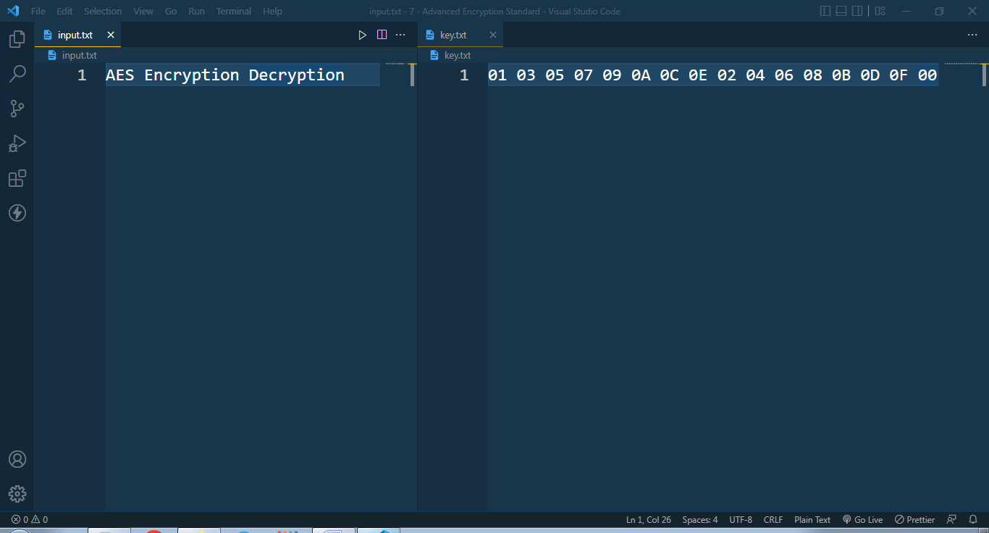

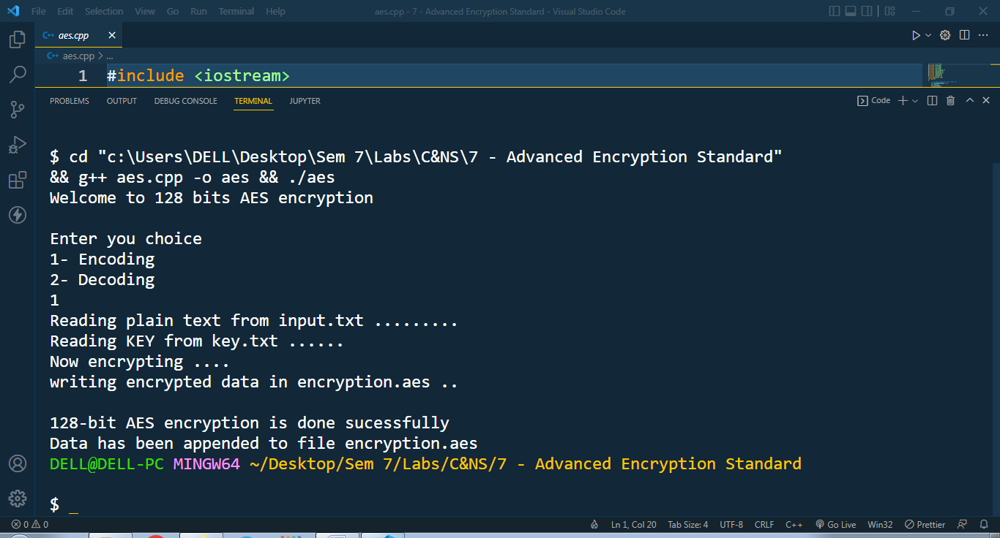

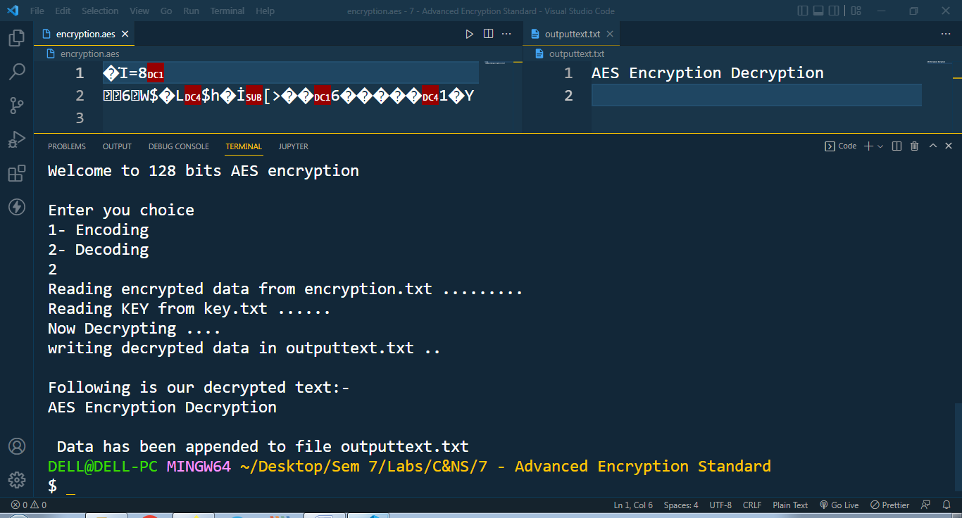

* **Conclusion:**

AES instruction set is now integrated into the CPU (offers throughput of several GB/s) to improve the speed and security of applications that use AES for encryption and decryption. Even though it’s been 20 years since its introduction we have failed to break the AES algorithm as it is infeasible even with the current technology.